

**THE STATE UNIVERSITY OF ZANZIBAR**

**SCHOOL OF SOCIAL AND NATURAL SCIENCE**

**DEPARTMENT OF SOCIAL SCIENCE**

**TUNGUU CAMPUS**

**COURSE CODE: INF 21O5**

**LECTURER: MASOUD MMANGA**

**REGISTRATION NO: BITAM/9/21/018/TZ**

**STUDENT NAME: JOHN SAGAWALA KOMBA**

QUESTION:1

import java.util.Scanner;

class Student { String regNo; String name; float cgpa;

String programName;

String schoolName;

String proctorName;

}

import java.util.Scanner; public class Main { public static void main(String[] args) {

Scanner AM = new Scanner(System.in) ;

System.out.print("Enter number of students: ") ; int n = AM.nextInt() ;

Student[] students = new Student[n] ;

AM.nextLine();

for (int i = 0; i < n; i++) { students[i] = new Student() ;

System.out.print("Enter student reg number " + (i + 1) + ": ") ; students[i].regNo = AM.nextLine() ;

System.out.print("Enter name of student " + (i + 1) + ": ") ; students[i].name = AM.nextLine() ;

System.out.print("Enter CGPA of student " + (i + 1) + ": ") ; students[i].cgpa = AM.nextFloat() ; sc.nextLine() ;

System.out.print("Enter program of student " + (i + 1) + ": ") ; students[i].programName = AM.nextLine() ;

System.out.print("Enter school name of student " + (i + 1) + ": ") ; students[i].schoolName = AM.nextLine() ;

System.out.print("Enter proctor name of student " + (i + 1) + ": ") ; students[i].proctorName = AM.nextLine() ;

}

for (int i = 0; i < n; i++) {

System.out.println("Details of student " + (i + 1) + ":") ;

System.out.println("Registration number: " + students[i].regNo) ;

System.out.println("Name: " + students[i].name) ;

System.out.println("CGPA: " + students[i].cgpa) ;

System.out.println("Programme name: " + students[i].programName) ;

System.out.println("School name: " + students[i].schoolName) ;

System.out.println("Proctor name: " + students[i].proctorName) ;

}

}

}

# QUESTION:2

}

}

}

if (section == 2) { for (int i = 5; i < 10; i++) { if (!seats[i]) {

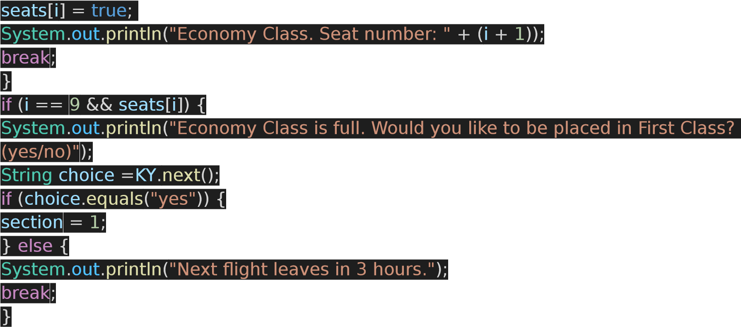

}

}

}

}

}

}

# QUESTION:3

class MathpremearLegue {

int standard; int numOfStudents; int[] marks; int firstMark;

public MathpremearLegue(int standard, int numOfStudents) { this.standard = standard; this.numOfStudents = numOfStudents; this.marks = new int[numOfStudents] ;

Scanner sc = new Scanner(System.in) ; for (int i = 0; i < numOfStudents; i++) {

System.out.print("Enter marks of student " + (i + 1) + ": ") ; marks[i] = sc.nextInt() ;

}

firstMark = marks[0] ; for (int i = 1; i < numOfStudents; i++) { if (marks[i] < firstMark) { firstMark = marks[i] ;

}

}

}

public void findBestClass() {

int maxStandard = 0; int maxFirstMark = 0; for (int i = 0; i < 4; i++) {

if (MathpremearLegue[i].firstMark > maxFirstMark) { maxStandard = MathpremearLegue[i].standard; maxFirstMark = MathpremearLegue[i].firstMark;

}

}

System.out.println("The standard with the highest first mark is: " + maxStandard) ;

}

public void findBestClass(int option) {

int maxStandard = 0; int maxAverage = 0;

int sum; int average;

for (int i = 0; i < 4; i++) { sum = 0;

for (int j = 0; j < MathpremearLegue[i].numOfStudents; j++) {

sum += MathpremearLegue[i].marks[j] ;

}

average = sum / MathpremearLegue[i].numOfStudents; if (average > maxAverage) {

maxStandard = MathpremearLegue[i].standard; maxAverage = average;

}

}

System.out.println("The standard with the highest class average is: " + maxStandard) ; }

}

public class Main {

public static void main(String[] args) {

MathpremearLegue] MathpremearLegue = new MathpremearLegue[4] ; for (int i = 0; i < 4; i++) {

System.out.print("Enter standard: ") ;

int standard = sc.nextInt() ;

System.out.print("Enter number of students: ") ;

int numOfStudents = sc.nextInt() ;

MathpremearLeguei] = new MathpremearLegue(standard, numOfStudents) ; }

MathpremearLegue.findBestClass() ;

MathpremearLegue.findBestClass(1) ;

}

}

# QUESTION:4

import java.util.Scanner; public class Details { public static void main(String[] args) {

Scanner za = new Scanner(System.in) ; System.out.println("Enter number of students:") ; int rows = za.nextInt() ;

System.out.println("Enter number of tests:") ; int cols = za.nextInt() ;

TestDetails TD = new TestDetails(rows, cols) ;

TD.storeMarks() ;

TD.displayMarks() ;

NoticePeriod NP = new NoticePeriod(rows, cols) ;

NP.countAndPrintNoticePeriodStudents() ;

}

}

import java.util.Scanner;

class TestDetails { float[][] marks; int rows, cols;

TestDetails(int rows, int cols) {

this.rows = rows; this.cols = cols;

marks = new float[rows][cols] ;

}

void storeMarks() {

Scanner sc = new Scanner(System.in) ; for (int i = 0; i < rows; i++) {

System.out.println("Enter number of tests taken by student " + (i + 1)) ; int testsTaken = sc.nextInt() ;

System.out.println("Enter marks scored in each test:") ;

for (int j = 0; j < testsTaken; j++) {

marks[i][j] = sc.nextFloat() ;

}

}

}

void displayMarks() {

System.out.println("Student marks:") ; for (int i = 0; i < rows; i++) {

System.out.print("Student " + (i + 1) + ": ") ;

for (int j = 0; j < cols; j++) { System.out.print(marks[i][j] + " ") ;

}

System.out.println() ;

}

}

}

class NoticePeriod extends TestDetails { NoticePeriod(int rows, int cols) { super(rows, cols) ;

}

void countAndPrintNoticePeriodStudents() { int count = 0;

System.out.println("Notice Period Students:") ;

for (int i = 0; i < rows; i++) { int testsTaken = 0, testsPassed = 0; for (int j = 0; j < cols; j++) { if (marks[i][j] != 0) { testsTaken++ ; if (marks[i][j] >= 50) { testsPassed++ ;

}

}

if (testsPassed >= 3) { break;

}

}

if (testsTaken < 3 || testsPassed < 3) { count++ ;

System.out.println("ID: " + (i + 1)) ;

}

}

System.out.println("Number of notice period students: " + count) ;

}

}

# QUESTION:5

import java.util.Random;

class SameColorBallException extends Exception{ public static void main (String[]args){

}

public SameColorBallException(String message){ super(message) ; }

class Main {

public static void main(String[] args) {

String[] colors = {"red", "green", "blue", "yellow"} ; int[] count = {0, 0, 0, 0} ;

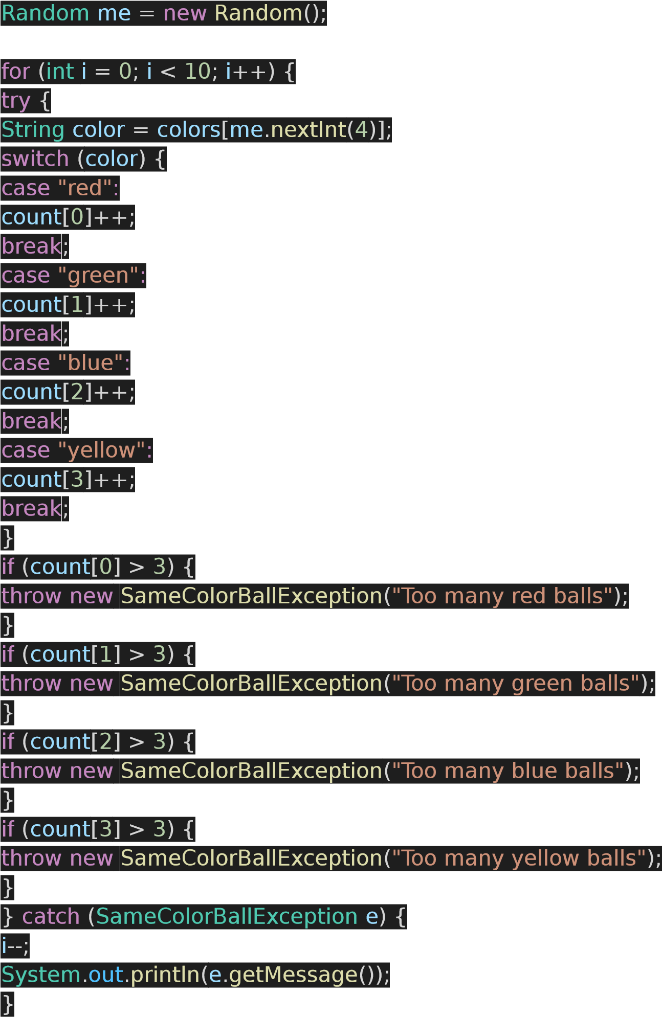

}

System.out.println("Number of red balls: " + count[0]) ;

System.out.println("Number of green balls: " + count[1]) ;

System.out.println("Number of blue balls: " + count[2]) ;

System.out.println("Number of yellow balls: " + count[3]) ;

}

}

}